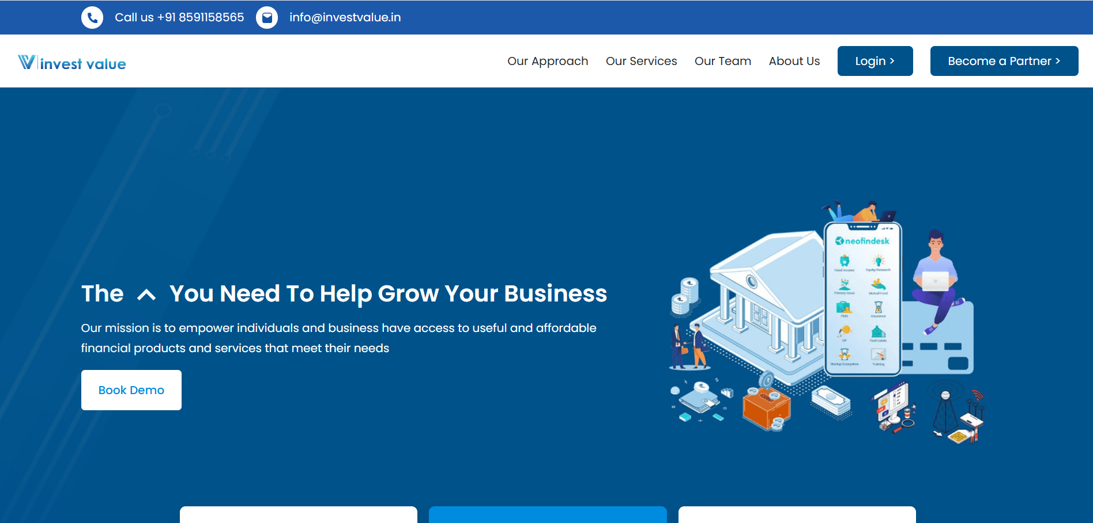

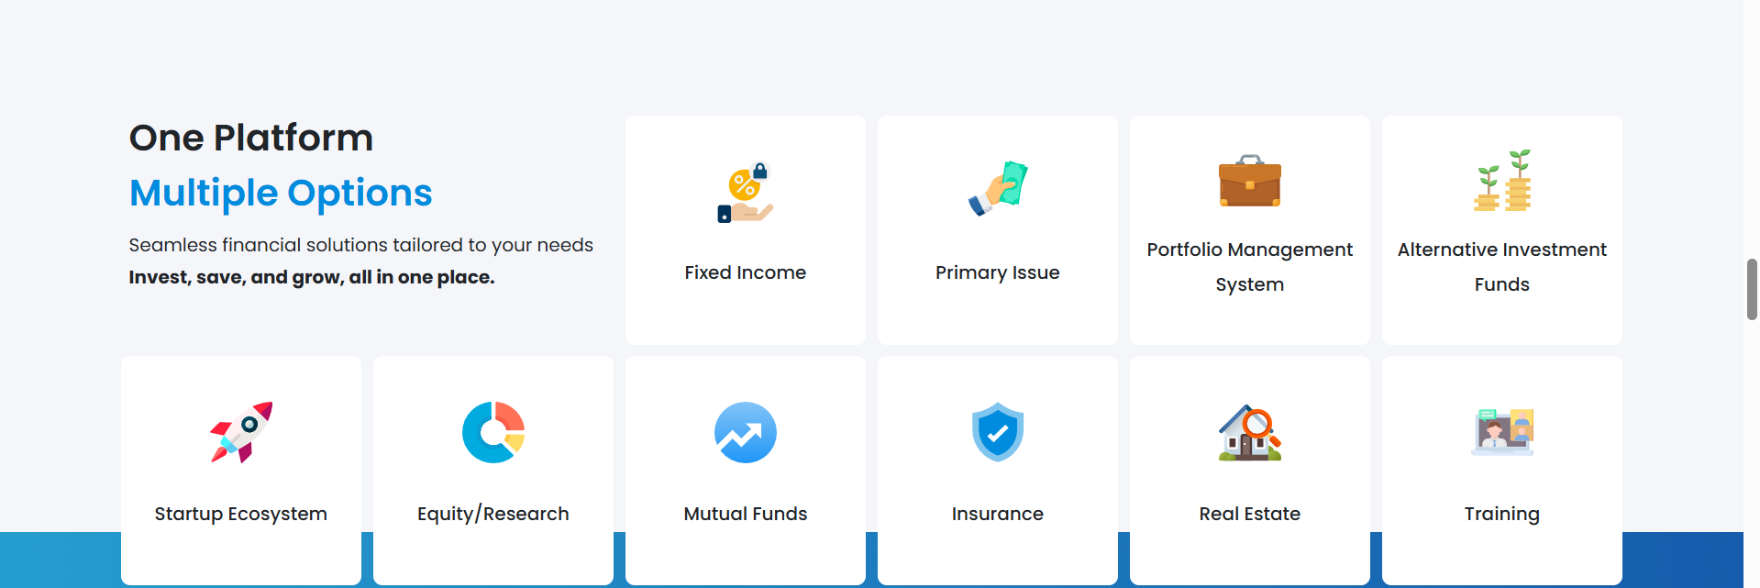

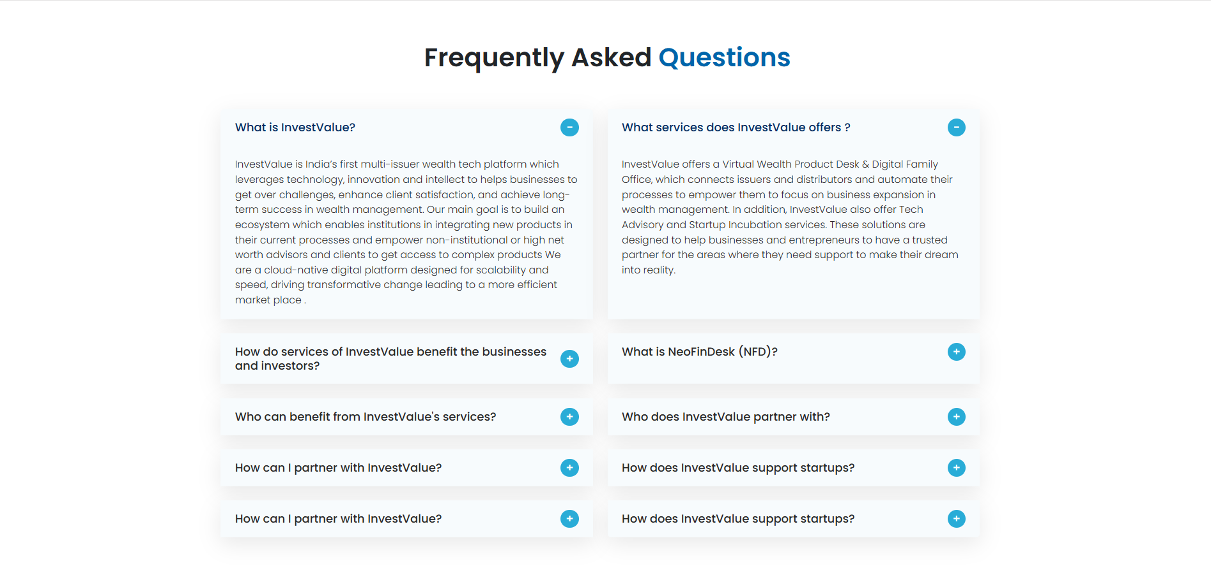

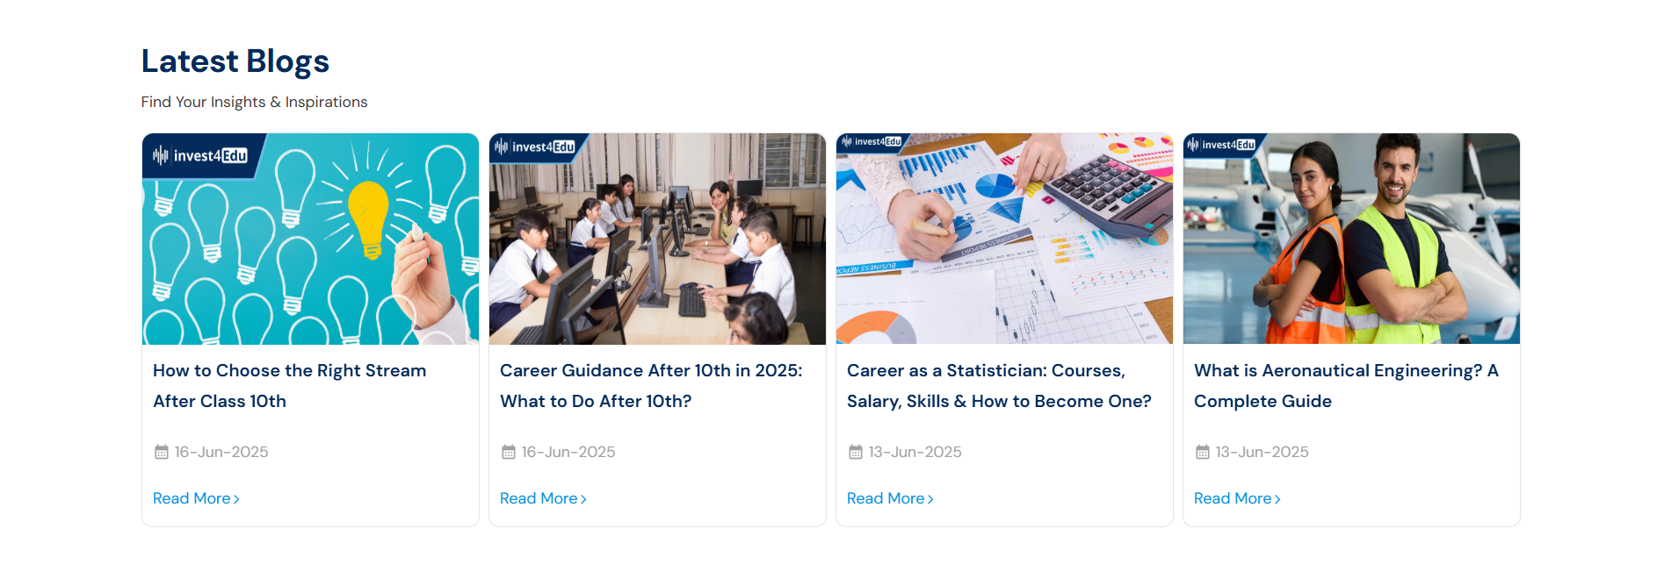

***Tasks like above screenshots and below topics in html/react***

login/signup pages

Home pages -banner sections

Col layouts

Grid layouts

Tables

Cards

Accordion/FAQ

Navbar sticky responsive

carousel

Modals

Create multiple components and showing in the single page

Create a form for login signup cards

Create a testimonial carousel

***QA***

Describe HTML layout structure.

What are tags and attributes in HTML?

What is the difference between the ‘id’ attribute and the ‘class’ attribute of HTML elements?

What are the various formatting tags in HTML?

What is the significance of <head> and <body> tags in HTML?

How do you specify a hyperlink in HTML and explain the target attribute?

What is semantic HTML? Can you give some examples of semantic tags?

How is an HTML form created and what are the common form input types?

What is the difference between inline, block, and inline-block elements?

Explain the concept of web storage

What is CSS and why is it used?

What is the difference between internal, inline, and external CSS?

What is the box model in CSS?

What is the difference between em, rem, and px?

How do you center a div vertically and horizontally?

What is the difference between “display: none” and “visibility: hidden

What are pseudo-elements? Provide examples.

What is the difference between relative, absolute, fixed, and sticky positioning?

How do media queries work in CSS?

Why do you use bootstrap?

What is a Bootstrap Container, and how does it work?

What do you know about the Bootstrap Grid System?

How do Bootstrap columns work?

How would you implement a carousel in bootstrap?

What are Bootstrap Breakpoints?

What is a Bootstrap Card and where would you use it?

How do you override default Bootstrap styles?

What is the difference between .container and .container-fluid?

What are the advantages of using React?

Explain about React components.

What are React hooks? Name a few commonly used ones.

What is useState() in React?

What is the purpose of useEffect() in React?

Explain React state and props.

What is the virtual DOM and how does React use it?

What is React Router and how does it work?